

**York Public Library’s MINI GOLF AT THE LIBRARY 2025**

**INSTRUCTIONS for Hole Decorators / Obstacle Creators**

Thank you for participating in *Mini-Golf at the Library!*

**York community groups — such as non-profits, schools, town agencies, and others — are invited to decorate / create “obstacles” for one of eighteen miniature golf holes during York Public Library’s Mini-Golf at the Library weekend on January 31 - February 1.** Holes are first-come, first-served.

This is an opportunity to be creative and fun – while at the same time represent your group or organization at this community event. The course will be open on Friday night January 31 during “Clubhouse Night” (fundraiser for ages 21+) and on Saturday, February 1 from 10am-4pm during Family Fun Day. Learn more about each event at yorkpubliclibrary.org/minigolf.

**WHAT THE LIBRARY PROVIDES:**

* The “greens”
* The hole numbers
* Hole bumpers
* The physical holes
* A simple sign by the start of the hole displaying your group name.

We have contracted with a company called [Library Mini-Golf LLC](https://libraryminigolf.com/) who will set up the course itself – including all of the basic elements such as the “greens”, the physical holes, bumpers, the flag, as well as the golf balls and golf clubs.

**WHAT YOU PROVIDE:**

* An item or items that serve as decorative obstacles for people to putt around. (See examples below.)
* Size: We have ample space in the library for each hole, but whatever you create should be able to fit in your car!
* Theme: It can be related to your group or mission, or you can pick whatever family-friendly theme you’d like. If you like dinosaurs, make a dinosaur themed hole! Do you have a favorite children’s book? That can be the theme!

**OTHER DETAILS:**

**When should I deliver our mini-golf hole obstacles to the Library?**   
We are setting up the course on Friday January 31 beginning at 10am. Please bring your obstacle(s) between 10am – 1 pm. Let us know if this window doesn’t work for you and we can make other arrangements.

**When should I pick up the obstacles from the Library?**We are dismantling the course on **Saturday, February 1 at 4PM.** If you are not able to reclaim your items on Saturday, you may do so on Monday morning, February 3 at 9AM.

**QUESTIONS? Please contact Jane Siviski Hoffman at 207-363-2818 ext. 1016 or email jshoffman@yorkpubliclibrary.org**

______________________________________________________________

**Examples of Holes (from our 2024 event)**

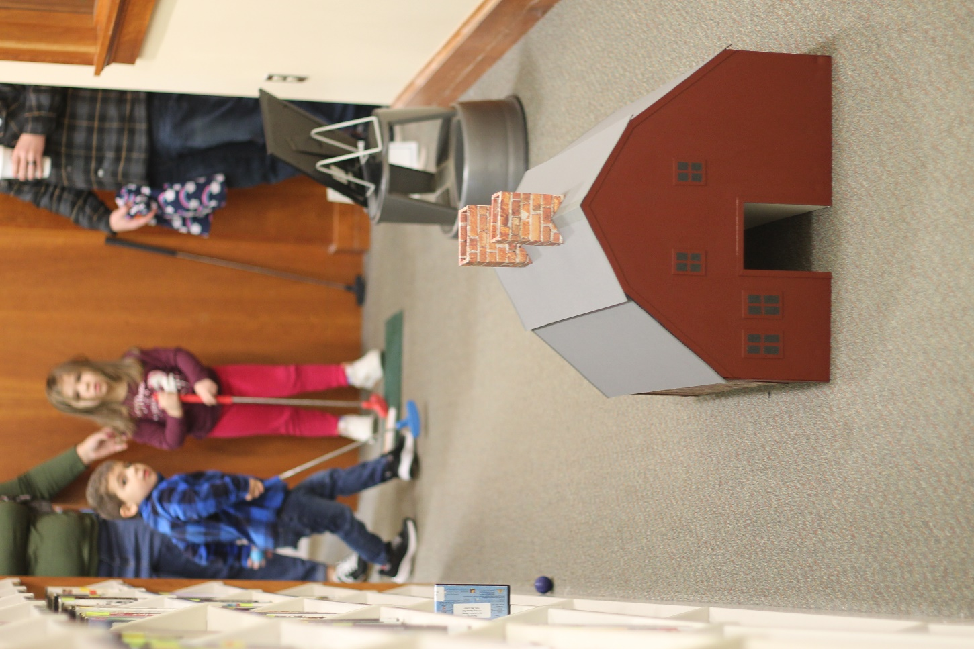

Old York Historical Society recreated the Old Gael in miniature.

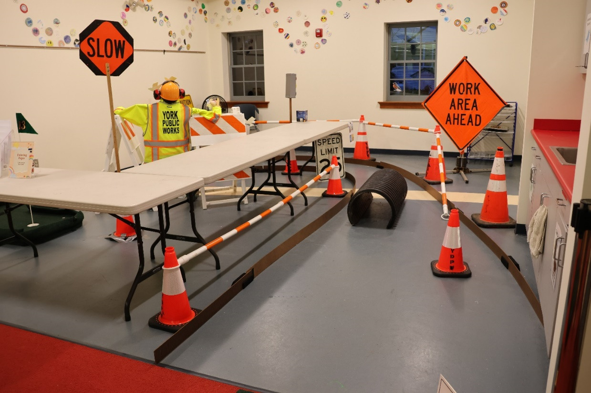

York Department of Public Works used some of their equipment and safety gear- the theme was PPE. (Personal Protective Equipment.)

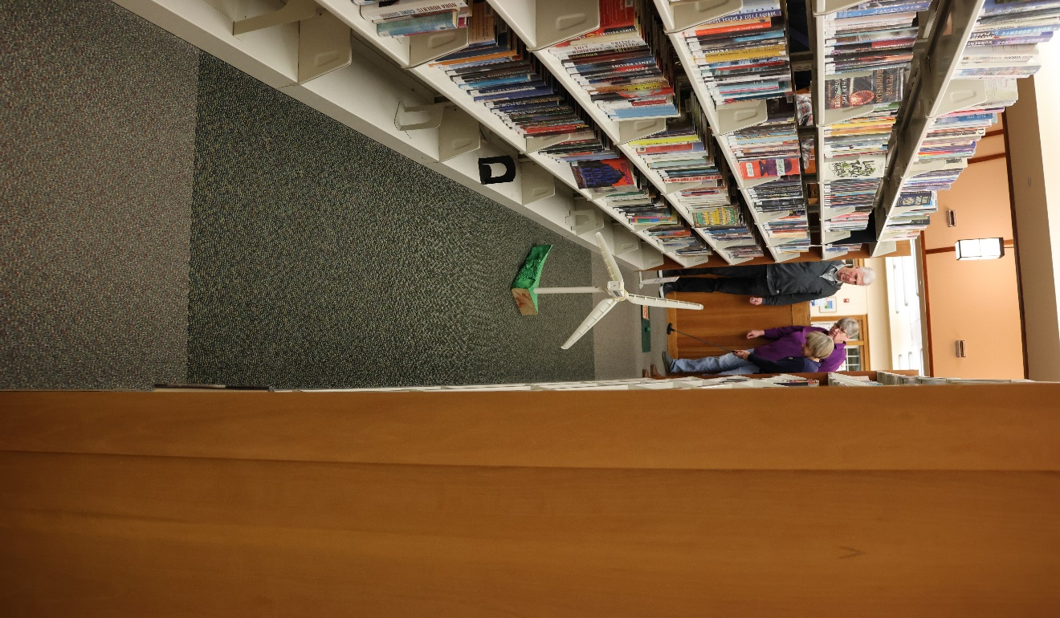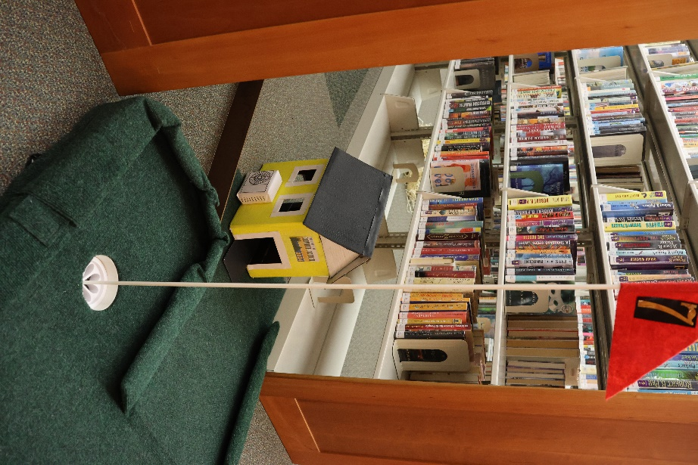  
York Ready for Climate Action focused on renewable energy and made a climate-friendly house and a wind turbine.

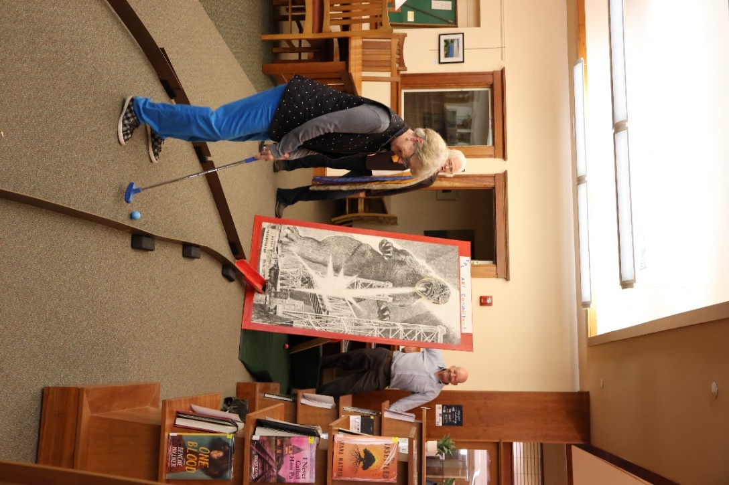

The York Public Library Art Committee repurposed a large Godzilla print.

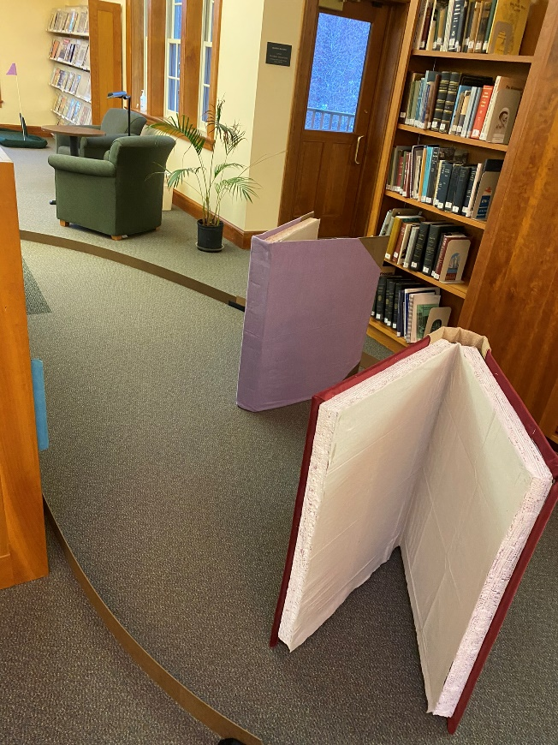

The York Public Library Association made giant books.