
York Public Library’s MINI GOLF AT THE LIBRARY 2026
INSTRUCTIONS for Hole Decorators / Obstacle Creators

Thank you for participating in Mini-Golf at the Library!
York community groups — such as non-profits, schools, town agencies, and others — are invited to decorate / create “obstacles” for one of eighteen miniature golf holes during York Public Library’s Mini-Golf at the Library weekend on February 6 - February 7. Holes are first-come, first-served.
This is an opportunity to be creative and fun – while at the same time represent your group or organization at this community event attended by hundreds of people. The course will be open on Friday night February 6 during “Clubhouse Night” (fundraiser for ages 21+) and on Saturday, February 7 from 10am-4pm during Family Fun Day. Learn more about each event at yorkpubliclibrary.org/minigolf.

WHAT THE LIBRARY PROVIDES:
- The “greens”
- The hole numbers
- Hole bumpers
- The physical holes
- A simple sign by the start of the hole displaying your group name.
We have contracted with a company called Library Mini-Golf LLC who will set up the course itself – including all of the basic elements such as the “greens”, the physical holes, bumpers, the flag, as well as the golf balls and golf clubs.

WHAT YOU PROVIDE:
- An item or items that serve as decorative obstacles for people to putt around. (See examples below.)
- Size: We have ample space in the library for each hole, but whatever you create should be able to fit in your car!
- Theme: It can be related to your group or mission, or you can pick whatever family-friendly theme you’d like. If you like dinosaurs, make a dinosaur themed hole! Do you have a favorite children’s book? That can be the theme!

OTHER DETAILS:
When should I deliver our mini-golf hole obstacles to the Library?
We are setting up the course on Friday, February 6 beginning at 10am. Please bring your obstacle(s) between 10am – 1 pm. Let us know if this window doesn’t work for you and we can make other arrangements.
When should I pick up the obstacles from the Library?
We are dismantling the course on Saturday, February 7 at 4PM. Please pick up your items at that time. If you are not able to reclaim your items on Saturday, please let us know and we can make other arrangements.

We can’t wait to see what you come up with! Questions? Please contact Jane Siviski Hoffman at 207-363-2818 ext. 1016 or email jshoffman@yorkpubliclibrary.org Thank you for your participation in this one-of-a-kind community event!
______________________________________________________________

Examples of Holes (from past events)
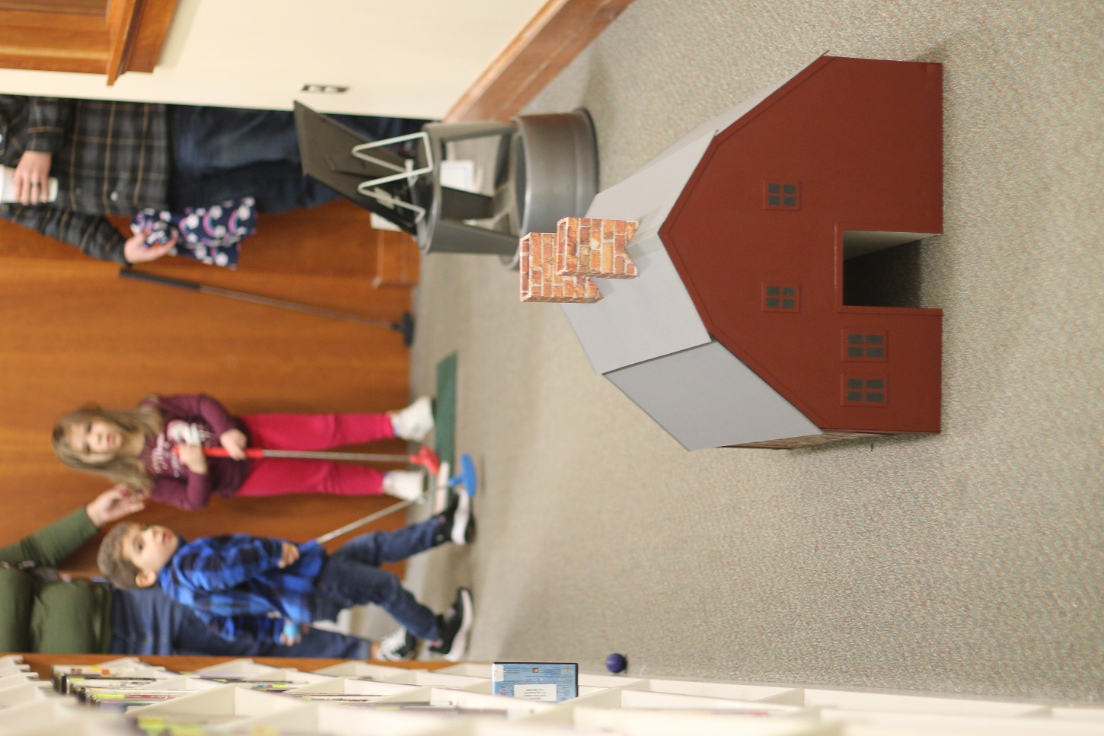
Old York Historical Society recreated the Old Gael in miniature.
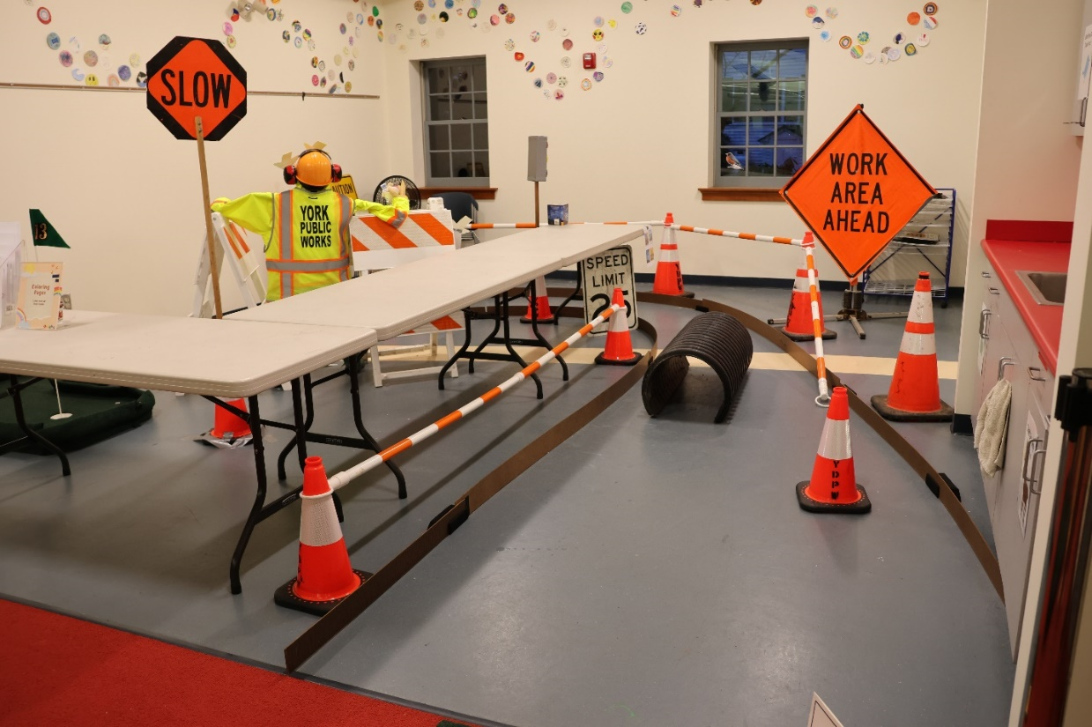
York Department of Public Works used some of their equipment and safety gear- the theme was PPE. (Personal Protective Equipment.)

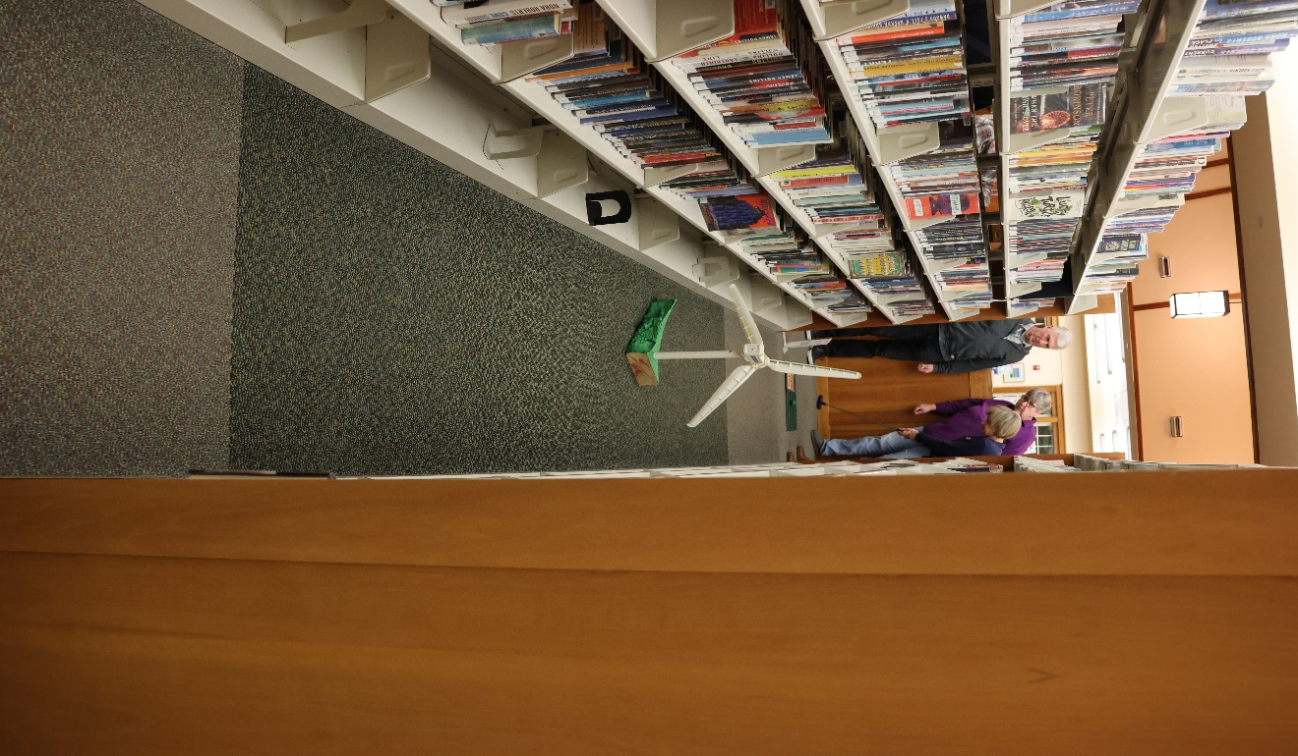
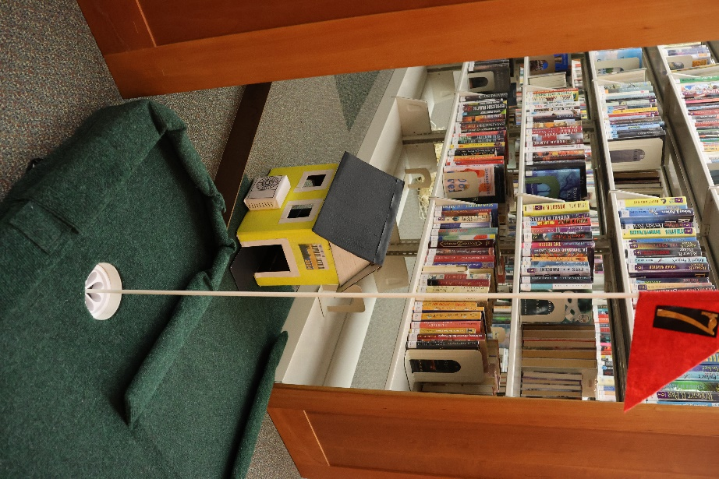
York Ready for Climate Action focused on renewable energy and made a climate-friendly house and a wind turbine.
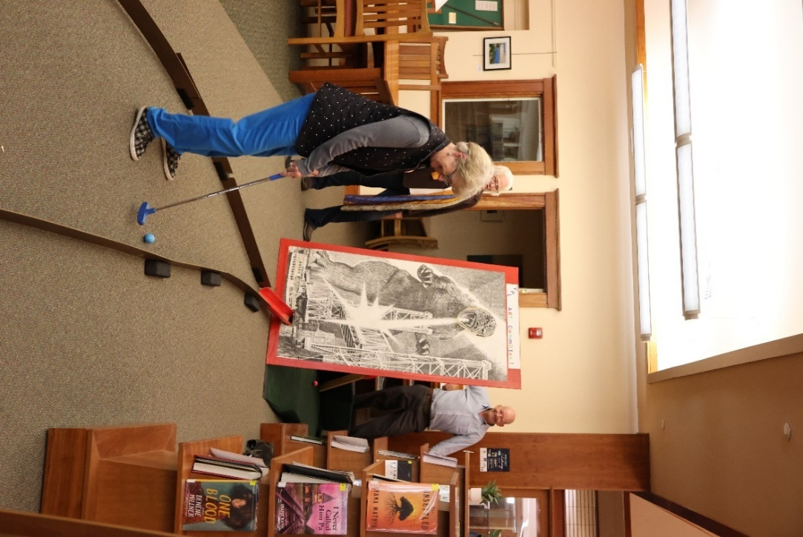
The York Public Library Art Committee repurposed a large Godzilla print.

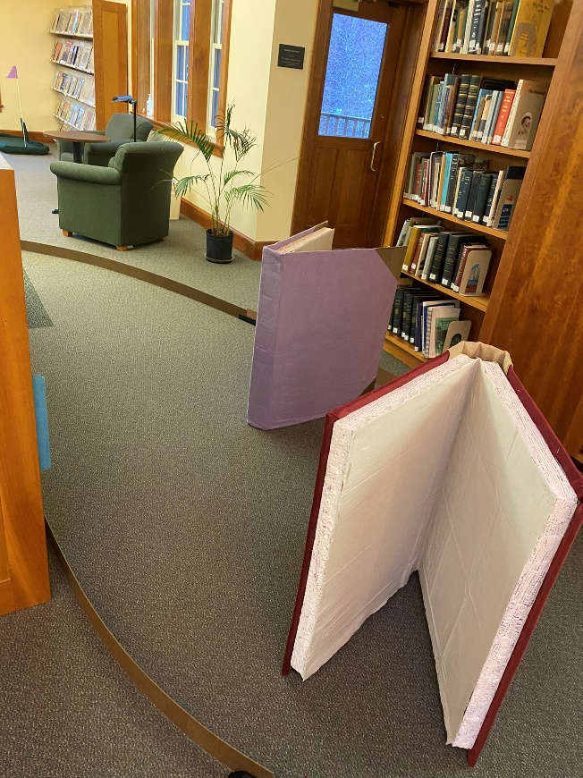
The York Public Library Association made giant books.

